**Recap on last week**

Ensure that you have created html files that include the following:

1. Table for staff directory information
   1. Caption included
   2. First row defined as a header
   3. Email addresses displayed as email links
2. Form with a variety of elements
   1. Input with a variety of types
      1. Text
      2. Checkbox
      3. Radio
      4. Password
      5. File
      6. Submit
      7. Reset
      8. Button
      9. File
      10. Color (note the spelling is Americanised)
   2. Fieldset
   3. Label
   4. Legend
   5. Select/option
   6. Textarea (textbox for multiple lines)
   7. Drop down lists
      1. With option to select multiple items from the list
3. Multimedia – Audio and Video

**CSS styling**

1. Download the CSS styling examples from Moodle:
   1. inline.html
   2. internal.html
   3. external.html
   4. mystyle.css
   5. id.html
   6. class.html
   7. div_span.html
2. Open the file ‘inline.html’ in an editor and notice the attributes inside the following elements
   1. <body>
   2. <h1>
   3. <p>
3. Preview the file in a browser and look at the formatting.
4. Change the background colour to a different colour of your choice.
5. Change the style <p> tag as follows:
   1. colour of purple
   2. centre alignment
6. Preview the file again in a browser and you should see the new formatting. Imagine if you had many paragraphs. Remember inline styling is not recommended but this is to show you how tedious and inefficient it would be to make inline changes. Eg if you had many <p> elements and wanted to change the style of all of them then you would need to manually change the value of the style attribute for each and every <p> element.
7. Close the file, saving changes.
8. Open the file ‘internal.html’ in an editor and notice the <style> element inside the <head> element.
9. Study the CSS syntax within the <style> element. Identify the following:
   1. Selector
   2. Property
   3. Value
10. Preview the file in a browser and look at the formatting. Don’t worry if it doesn’t look normal as it is to demonstrate the different styles which have been applied to the different elements.
11. Make the following changes:
    1. Change the background colour of the <body> element to a different colour of your choice.
    2. Change the colour of <h1> element to a different colour of your choice.
    3. Change the alignment of <p> element to ‘left’.
    4. Insert new code within <style> element which should be applied to <h2> and <h3> elements.
12. Preview the file again in a browser and you should see the new formatting.
13. Close the file, saving changes.
14. Open the file ‘external.html’ in an editor and notice the <link> element inside the <head> element.
15. Look at the attributes inside <link> element. The value of the ‘href’ attribute is the actual css file which is completely separate from the ‘.html’ file.
16. Open the file ‘mystyle.css’ in an editor. Note that there is NO html code as this should only contain CSS syntax.
17. Preview the file ‘external.html’ in a browser and check how the CSS styling within the CSS file has been applied to the different elements within the ‘.html’ file.
18. Make changes to style of the elements inside ‘mystyle.css’.
19. Add new CSS code which can be applied to <p> elements.
20. Save the changes to the CSS file.
21. Preview the file ‘external.html’ file again in a browser and check that the new formatting has been applied.
22. Close the file ‘external.html’, saving changes.
23. Open the file ‘id.html’ in an editor and look at the code for creating an id called intro and how it is applied to <h1> element.
24. Close the file, saving changes.
25. Open the file ‘class.html’ in an editor. Notice that the class called ‘center’ has been created as a general class meaning that it can be applied to different elements. Check the attributes inside <h1> and <h2> elements.
26. Preview the file ‘class.html’ in a browser and check that the style of the new class has been applied to the relevant elements.
27. Create a new class called ‘highlight’ which applies a background colour of yellow.
28. Apply the new class to some but not all of <p> elements.
29. Preview the file again in a browser and check that the style of the new class has been applied to the relevant elements.
30. Close the file, saving changes.
31. Open the file ‘class2.html’ in an editor. Look at the code for creating and applying classes. Many of the styles have been defined in a class with an appropriate name and then the classes have been applied to specific elements, mainly paragraphs for simplicity. For example:
    1. .bold{font-weight:bold;}
    2. <p class="bold">Cu duo falli appareat interpretaris, ……. </p>
32. Preview the file ‘class2.html’ in a browser and preview the different styles.
33. Close the file, saving changes.
34. Open the file ‘div_span.html’ in an editor. Notice the use of the <div> element to embed <h1>, <h2> and the first <p> element.
35. Preview the file ‘div_span.html’ in a browser and check that the style of the new class has been applied to the first three elements within <body> even although it has only been applied to <div> element once.
36. Notice the use of the <span> element to apply a style to only a part of an element.
37. Make some changes of your own and check that these can be previewed in a browser.
38. Close the file, saving changes.
39. Open html files created in earlier labs and make sure that there are a variety of elements in the files so that you can apply a variety of styles to them:
    1. eg h1, h2, p, a, img, ol, li, dl, table, th, tr
40. Apply different styles to these elements using internal styles
    * Colour – try using names and hexadecimal values
    * Alignment
    * Font
    * Text size
    * Border
    * Background colour
41. Once the styles are all working in the browser, move some of them into an external file. Make sure you save the external file with a .CSS extension.
42. Add code within the <head> element inside the .html document which links to the external file.
43. Preview the html document in a browser and check that all internal and external styles are still working

**CSS Layout**

1. Download the CSS layout examples from Moodle:
   * layout1-7
   * two_footers
   * newspapers
   * horizontal _menu
2. Study the code in each file and make changes to produce other layouts for a web page.
3. Example – layout1
   * Container
   * Header
   * Nav
   * Content
   * Footer

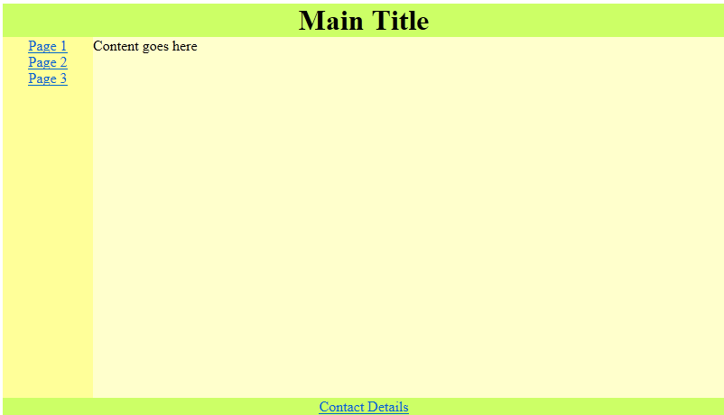

1. Example –layout2
   * Container
   * Header
   * Article
   * Aside
   * Footer

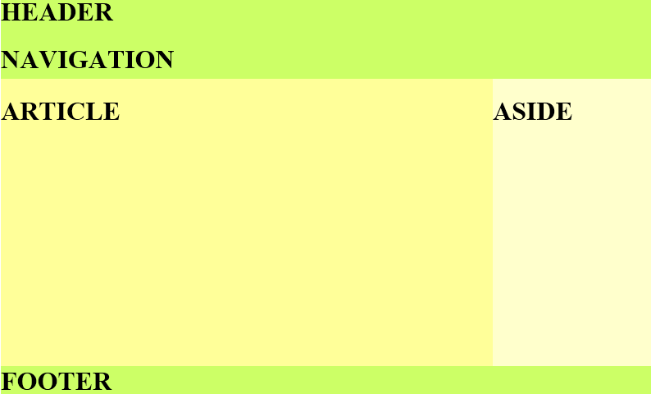

1. Example – layout3

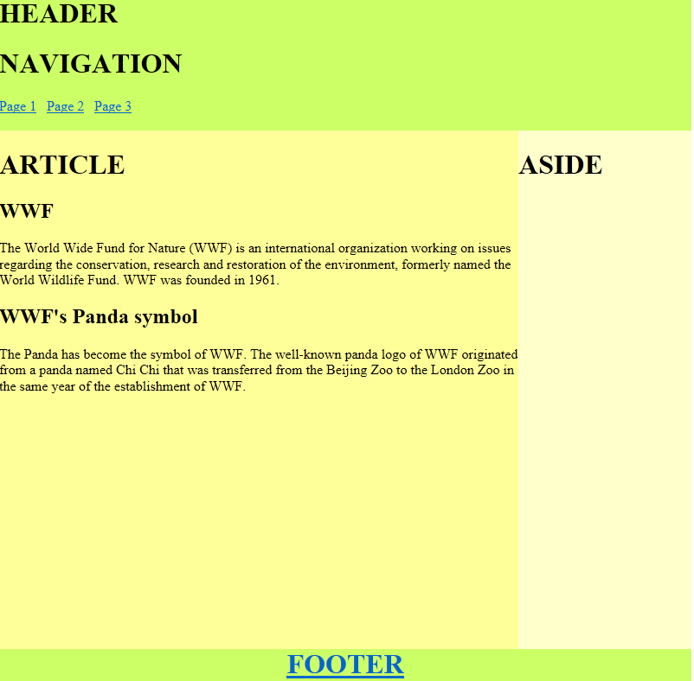

1. Example – layout7

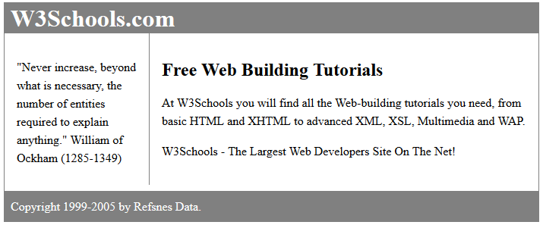

1. Example – horizontal_menu

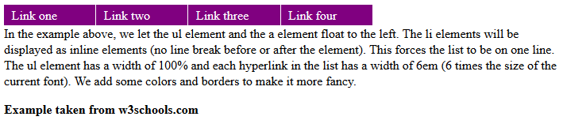

**More CSS Exercises**

1. Download ‘more CSS examples‘ from Moodle.
   * div, position, overflow, float, clear
2. Add different properties of the <div> element such as width, padding, border and margin. Work through the ‘Div’ exercises in the following order:
   * div1.html
   * div2.html
   * div3.html
   * div4.html
3. Change the value of the position property such as relative, absolute, fixed. Work through the ‘Position’ exercises in the following order
   * position1.html
   * position2.html
   * position3.html
   * position4.html
4. Open the file ‘overflow.html’ file and change the value of the overflow property such as visible, hidden and scroll.
5. Open the file ‘float.html’ file and change the value of the float property such as left, center and right.